Hello IMSA FUSION Partner Schools!
IMSA FUSION Quarterly Program Updates are designed to inform you of important FUSION news, information and deadlines. Please carefully read these updates and contact our team if you have any questions!
Change the Equation (CTEq) IMSA FUSION is thrilled to announce our official induction into Change the Equation STEM Works, a national coalition of corporations committed to identifying and supporting effective STEM programming across the country. FUSION was ranked among the top STEM programs in the nation by this notable coalition. Thank you to all of our partner schools for making FUSION a success! To learn more, visit: http://changetheequation.org/improving-philanthropy/stemworks
Parent Events
We are excited about upcoming parent events! For FUSION schools of three years or more, you recently received our parent night power point and some sample hands-on family activities. Good luck with your FUSION kickoff! If you are a first or second year partner school, please invite us to your parent event to help you get your program started. Send your parent night event date/time to Program Assistant, Sandy Kehl, skehl@imsa.edu, and to your IMSA FUSION Site Support Specialist as soon as possible. The following materials are attached to help you plan your event and execute the application/selection process:
1. Parent night overview, recommended agenda
2. FUSION brochure in English/Spanish (IMSA staff will bring these to distribute; veteran schools can distribute as needed)
3. Student criteria for selection
4. Student application rubric to help you rate applications and diversify your participant group, as needed. Feel free to modify this rating form to meet the needs of your school population.
Remember, you will distribute your program applications for invited students that have met our criteria during your parent event. Application materials, all necessary paperwork, and other tools and templates for your FUSION needs have been provided on your flash drive at the POP Workshop.
Student Paperwork Due October 15, 2012
We encourage you to get your program off and running soon to fulfill your 64 hours of contact time for the year! Field trips and parent events count as program time, of course! After students apply and are selected, you will need to submit necessary paperwork to IMSA. To request any additional forms in Spanish, please contact Curriculum Materials Manager, Amanda Lee, amlee@imsa.edu. Paperwork to collect from students and send to us includes the following:
1. New OR Continuing IMSA FUSION Student Application Form (send originals to IMSA)
2. Teacher Recommendation Form (keep on file at your school)
3. Photo/Video Permission (send originals to IMSA)
4. Student T-Shirt Request Form (send ONLY one t-shirt SUMMARY FORM for entire group to IMSA)
5. IMSA FUSION Evaluation/Transcript Study Consent (send originals to IMSA)
6. Student Essay (keep on file at your school)
After officially selecting your FUSION students and collecting student paperwork, please provide forms, per above, to your Site Support Specialist OR send them by mail to:
Sandy Kehl, IMSA FUSION Program Assistant
Illinois Mathematics and Science Academy
1500 Sullivan Rd.
Aurora, IL 60506
FUSION Needs
This year we are asking our schools to please:
1. Remember to submit detailed feedback after each FUSION session with students. There will be no coordinator form this year.
2. Properly count and inventory kit materials for return to IMSA after each semester.
3. Work to recruit and retain a full FUSION group of students (30 6-8th graders and 20 4-5th graders). Fill available slots with kids from your waiting list, if and when possible.
4. Send photos and video links to FUSION Curriculum Materials Specialist, Amanda Lee, amlee@imsa.edu
The FUSION W.A.L.L.
Attached you will find the FUSION W.A.L.L. which brings you up-to-date grant opportunities for K-12 teachers focusing on STEM (Science, Technology, Engineering and Math). This resource offers information on awards, fundraisers, professional development opportunities, field trips and even "freebies". The W.A.L.L. is also located on our website for your reference: https://www3.imsa.edu/programs/fusion/whatsnew. Please let us know how we can support you in grant opportunities to enhance your FUSION program!
STEM (Science, Technology, Engineering, Math) Career Webinars
Mark your calendars for THREE interactive online STEM Career Webinars. Meet real scientists and learn about exciting research and work being done today! Sessions run from 3:00 PM to 4:15 PM with tech checks available prior to the event!
Τυεσδαψ, Οχτοβερ 30, 2012
Ωεδνεσδαψ, ϑανυαρψ 30, 2013
Τηυρσδαψ, Απριλ 25, 2013
...Stay tuned for news in early September about 6-8th grade Math and Science Inquiry Field Trips to IMSA!
News from the Illinois Mathematics and Science Academy
The Illinois Mathematics and Science Academy enrolls academically talented Illinois students (grades 10-12) in its advanced, residential college preparatory program. The 650 students who attend the three-year residential program participate in a unique approach to learning that is problem-centered, inquiry-based and integrative. Research, leadership and service are fundamental components of the IMSA learning environment. Applications for the Class of 2016 and the 2013-2014 academic year will be available in September 2012.
Experience IMSA
...On campus - during Preview Days in November & January or at 2-Hour Tours held during the academic year. Dates and times are listed at: www.imsa.edu/admissions/gettoknow. ALSO on campus -PROMISE - Project School Visit (PSV) for high minority, low income schools- FREE STEM (Science, Technology, Engineering and Math) field trip to the Illinois Math and Science Academy - Includes Science Laboratory Experience, Tour of IMSA and Lunch! To schedule a PSV, contact Adrienne Coleman at acoleman@imsa.edu.
...On the web - www.imsa.edu/admissions to find information about application process, to take the CyberQuiz or even find out more about life at IMSA from our student ambassador blog
...On the road - in your area at an informational meeting in or near your hometown. Dates and locations are listed at: www.imsa.edu/admissions/gettoknow/info_meetings
...PROMISE - Leading Students to Success (LS2S) and Early Involvement Program (EIP)- FREE STEM (Science, Technology, Engineering and Math) Enrichment Program for 6th - 9th graders on Saturday's - Through an inquiry based learning approach, students will enhance their math, science and communication skills while preparing for the ISAT and SAT exams. To learn more about LS2S and EIP, please contact Adrienne Coleman at acoleman@imsa.edu.
Welcome to IMSA's new Chicago Field Office Coordinator
Sarah Antrium-Cambium previously worked at IMSA as part of the Illinois Virtual High School. Most recently, Sarah served as a Spanish teacher at Beasley Magnet in Chicago. Sarah's experience in working with Chicago Public Schools along with her experience in online teaching and learning will be great assets to IMSA Professional Field Services. Please contact Sarah to learn about IMSA programming in Chicago at chicagooffice@imsa.edu.
Thank you for all you do to ignite and nurture the talents of our FUSION students across Illinois! We are looking forward to an amazing 2012-13 FUSION year!
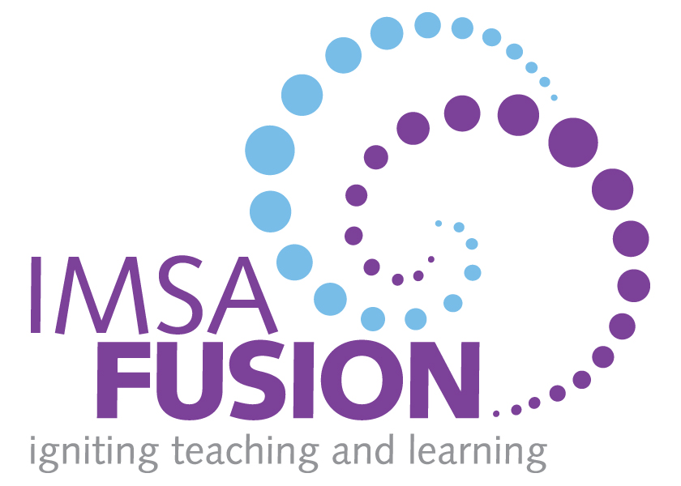
The IMSA FUSION Team

