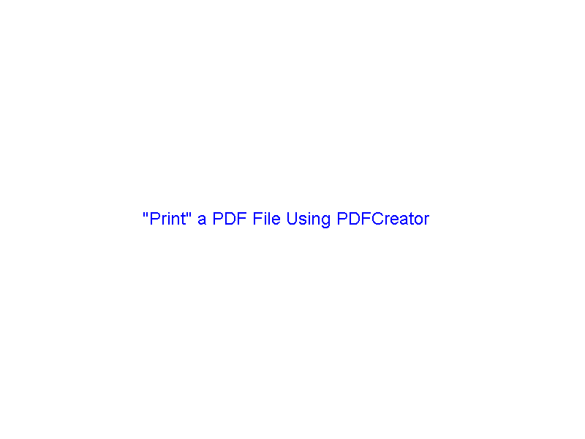

"Print" a PDF File Using PDFCreator

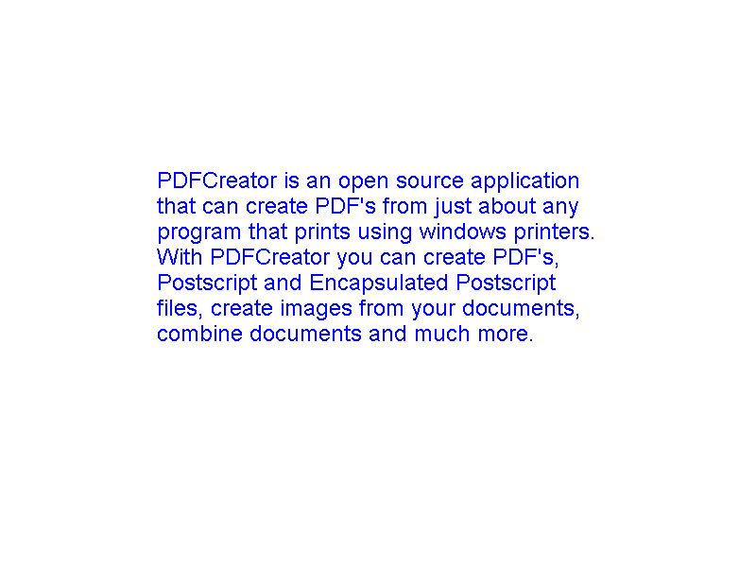

PDFCreator is an open source application that can create PDF's from just about any program that prints using windows printers. With PDFCreator you can create PDF's, Postscript and Encapsulated Postscript files, create images from your documents, combine documents and much more.

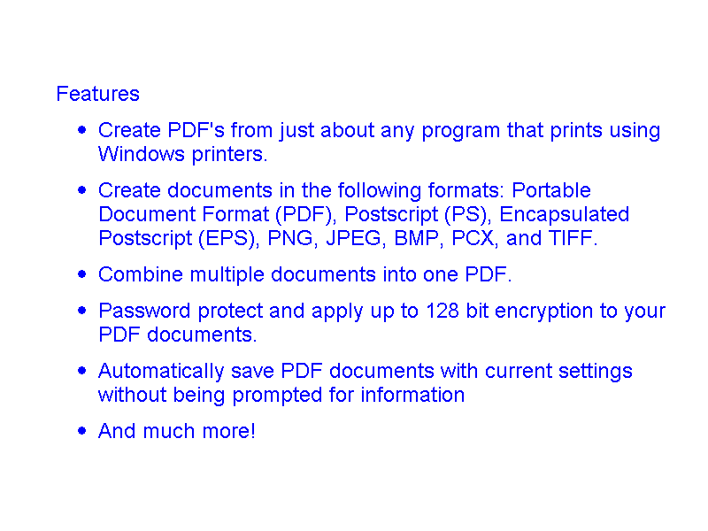

Features
- Create PDF's from just about any program that prints using Windows printers.
- Create documents in the following formats: Portable Document Format (PDF), Postscript (PS), Encapsulated Postscript (EPS), PNG, JPEG, BMP, PCX, and TIFF.
- Combine multiple documents into one PDF.
- Password protect and apply up to 128 bit encryption to your PDF documents.
- Automatically save PDF documents with current settings without being prompted for information
- And much more!

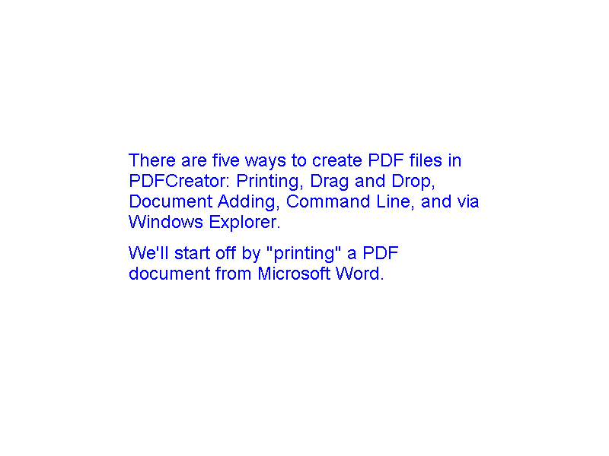

There are five ways to create PDF files in PDFCreator: Printing, Drag and Drop, Document Adding, Command Line, and via Windows Explorer.
We'll start off by "printing" a PDF document from Microsoft Word.

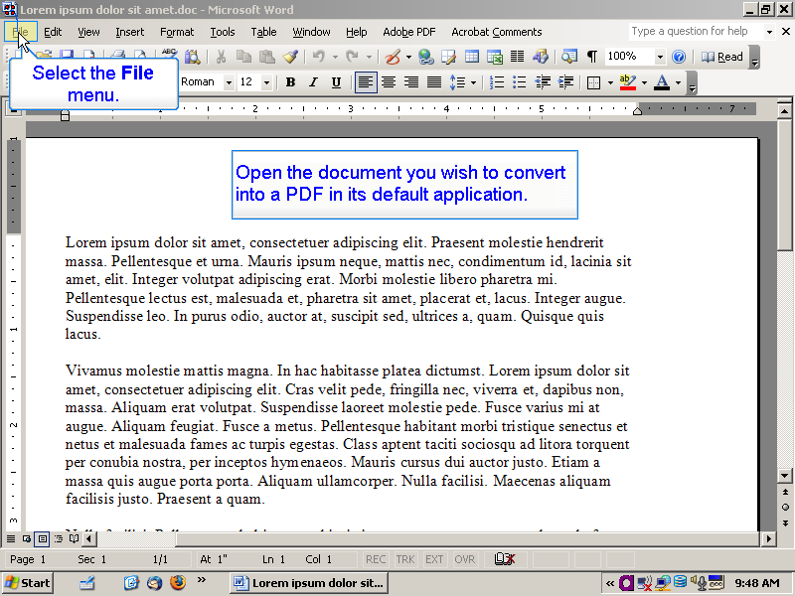

Open the document you wish to convert into a PDF in its default application.

Select the File menu.

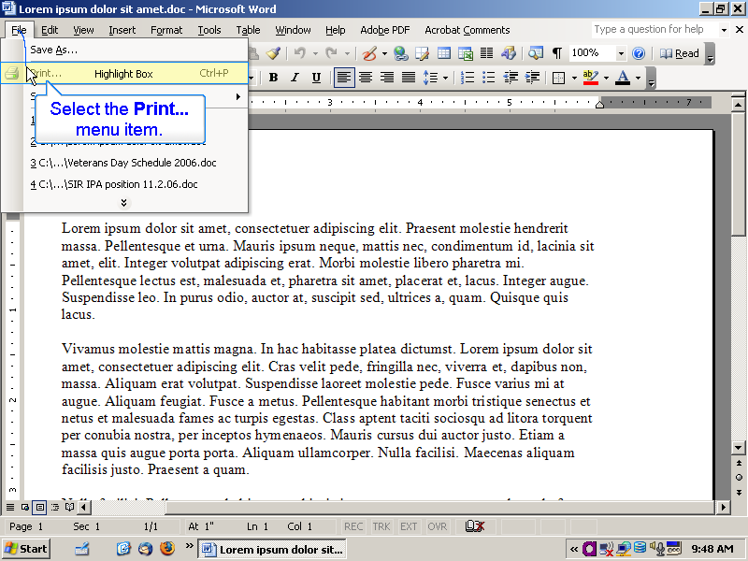

Select the Print... menu item.

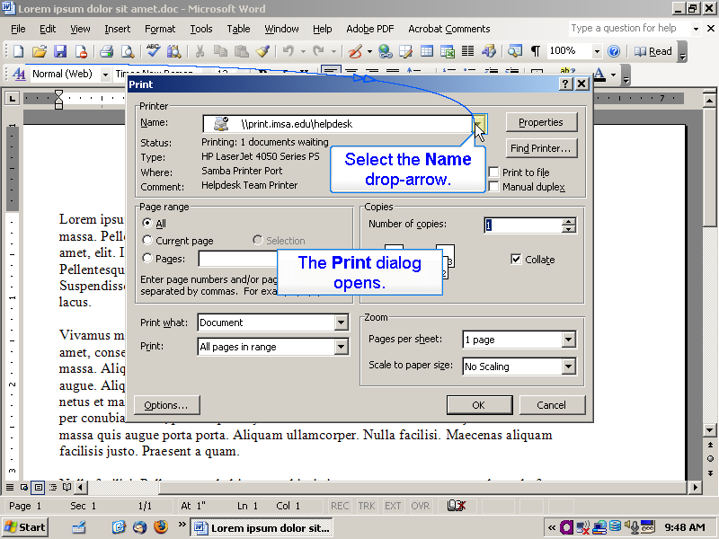

The Print dialog opens.
Select the Name drop-arrow.

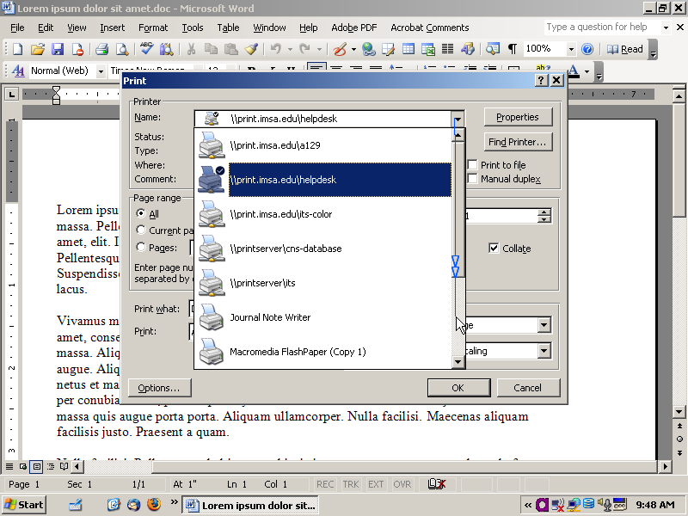

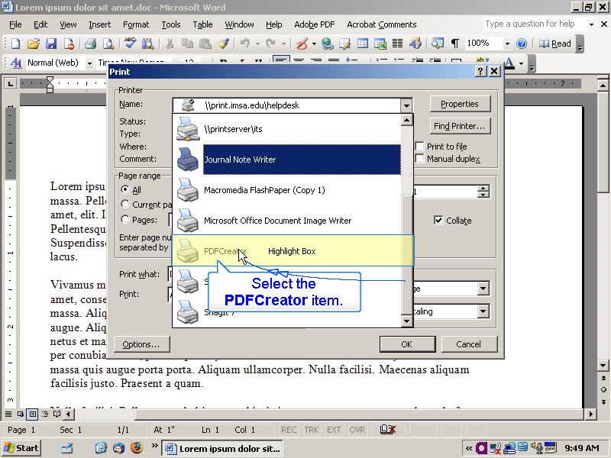

Select the PDFCreator item.

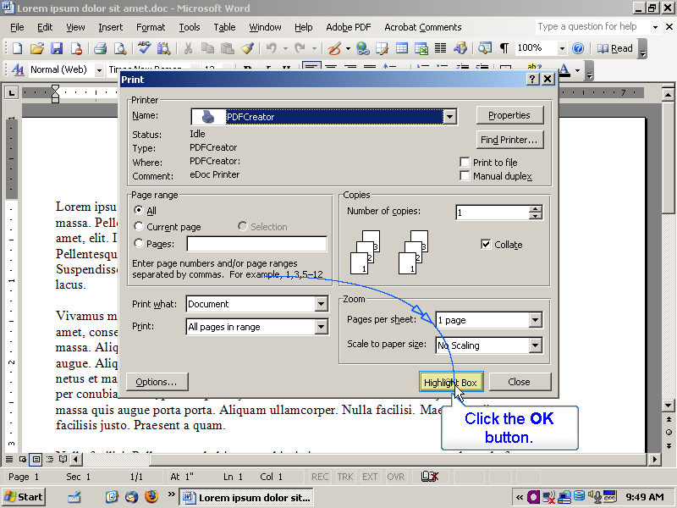

Click the OK button.

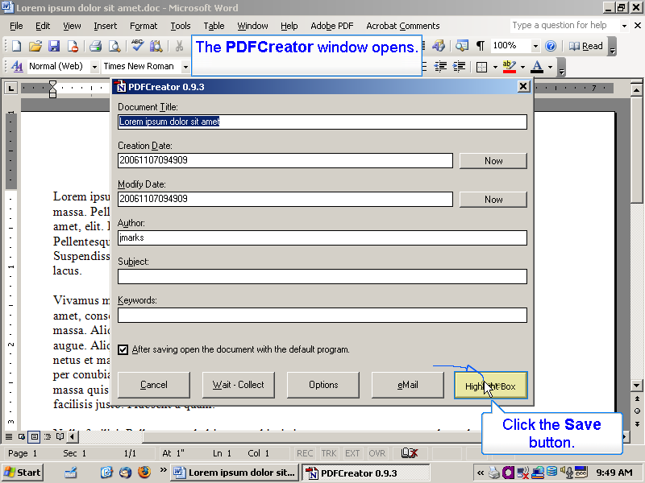

The PDFCreator window opens.
Click the Save button.

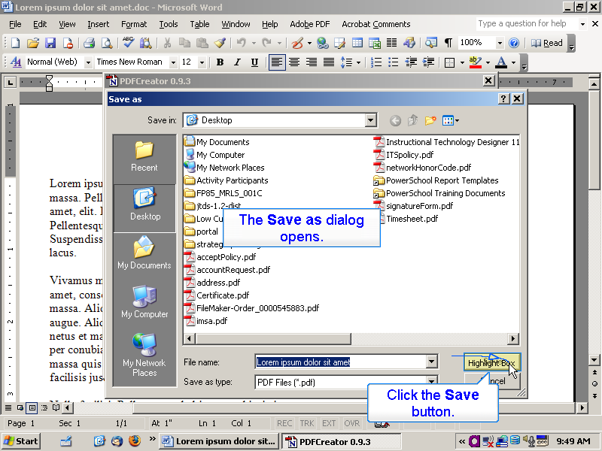

The Save as dialog opens.
Click the Save button.

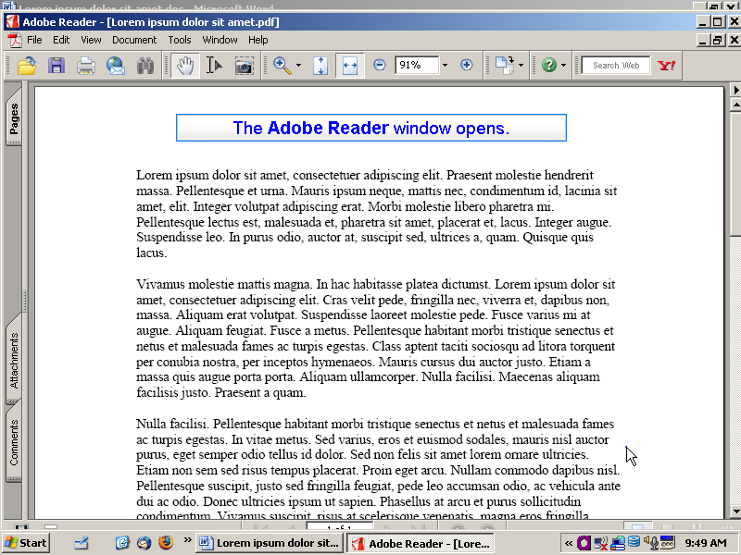

The Adobe Reader window opens.

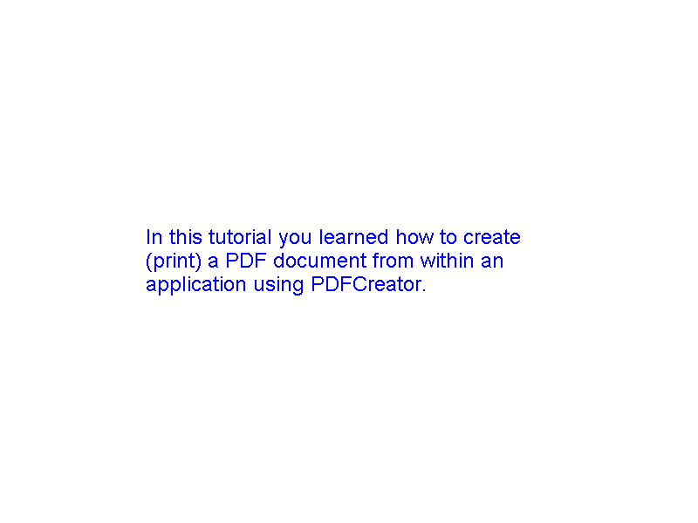

In this tutorial you learned how to create (print) a PDF document from within an application using PDFCreator.

