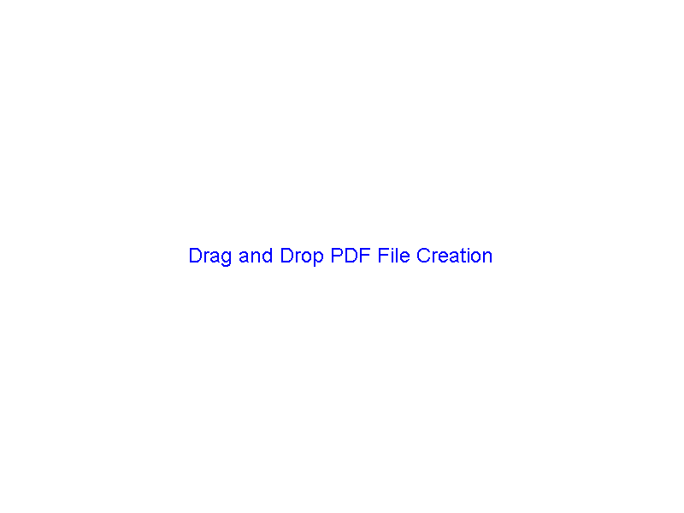

Drag and Drop PDF File Creation

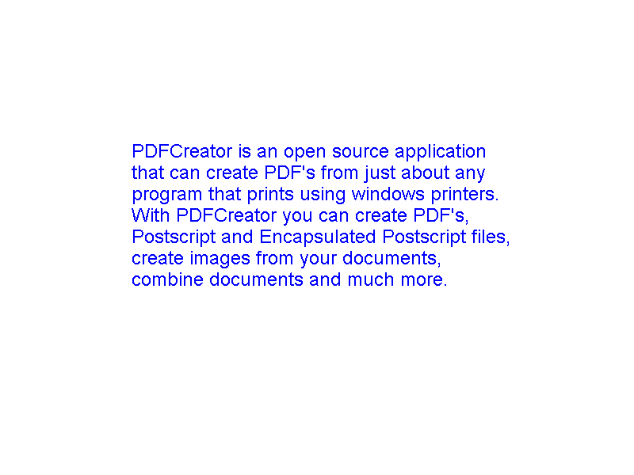

PDFCreator is an open source application that can create PDF's from just about any program that prints using windows printers. With PDFCreator you can create PDF's, Postscript and Encapsulated Postscript files, create images from your documents, combine documents and much more.

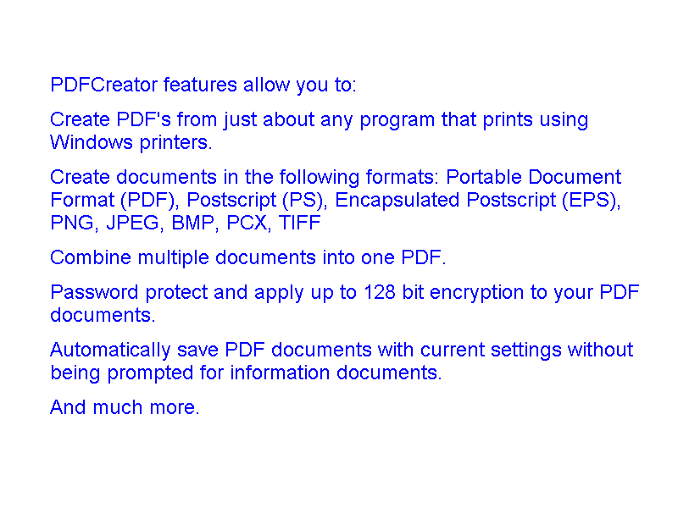

PDFCreator features allow you to:
Create PDF's from just about any program that prints using Windows printers.
Create documents in the following formats: Portable Document Format (PDF), Postscript (PS), Encapsulated Postscript (EPS), PNG, JPEG, BMP, PCX, TIFF
Combine multiple documents into one PDF.
Password protect and apply up to 128 bit encryption to your PDF documents.
Automatically save PDF documents with current settings without being prompted for information documents.
And much more.

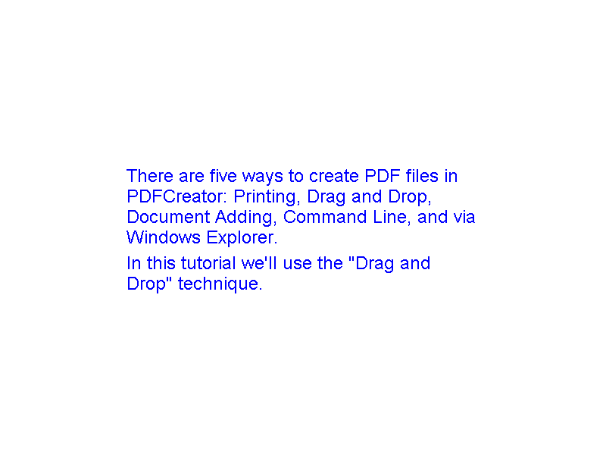

There are five ways to create PDF files in PDFCreator: Printing, Drag and Drop, Document Adding, Command Line, and via Windows Explorer.
In this tutorial we'll use the "Drag and Drop" technique.

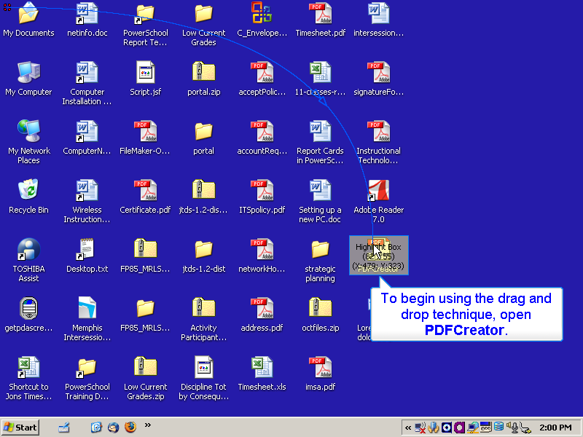

To begin using the drag and drop technique, open PDFCreator.

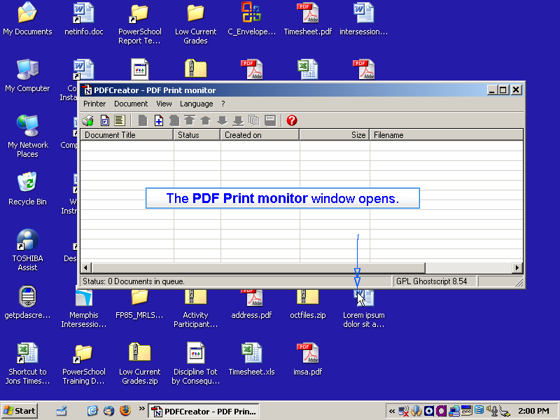

The PDF Print monitor window opens.

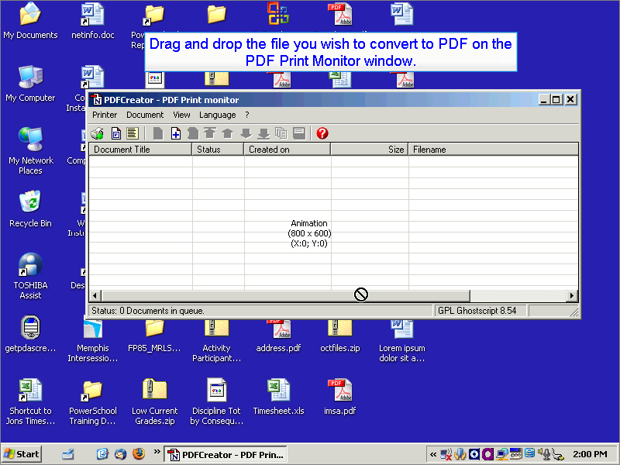

Drag and drop the file you wish to convert to PDF on the PDF Print Monitor window.

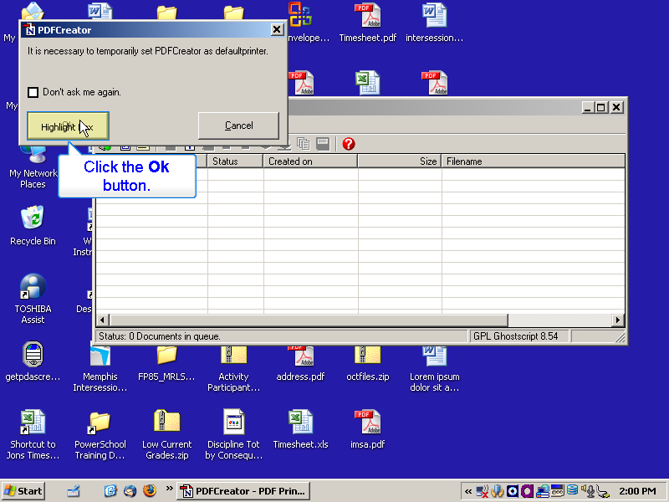

Click the Ok button.

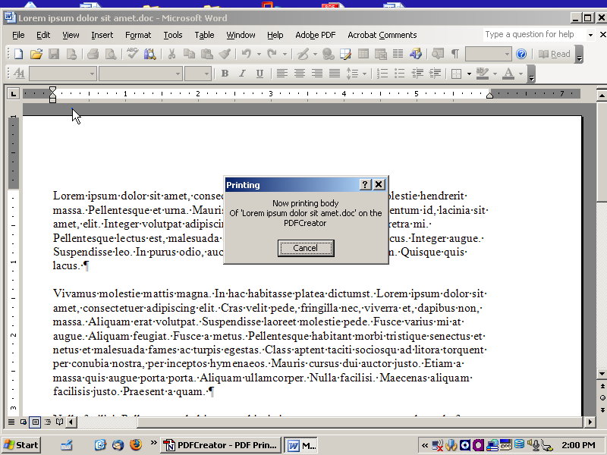

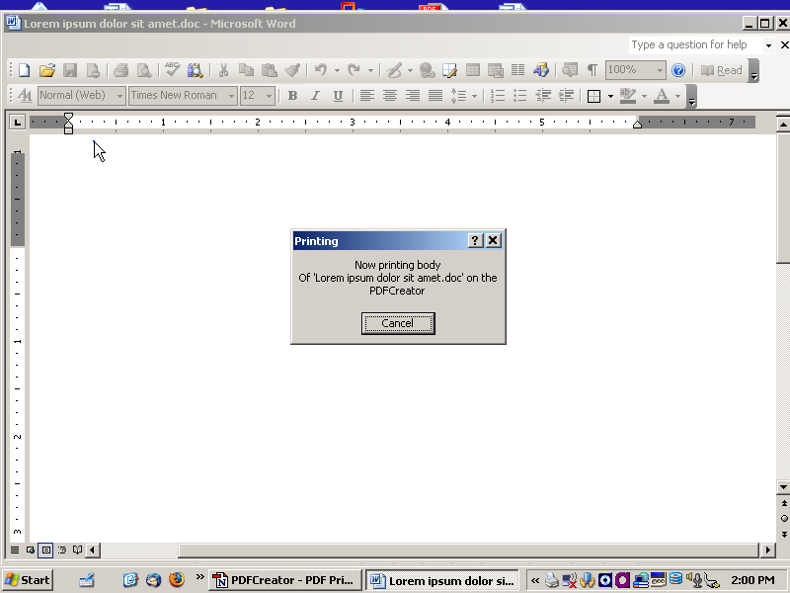

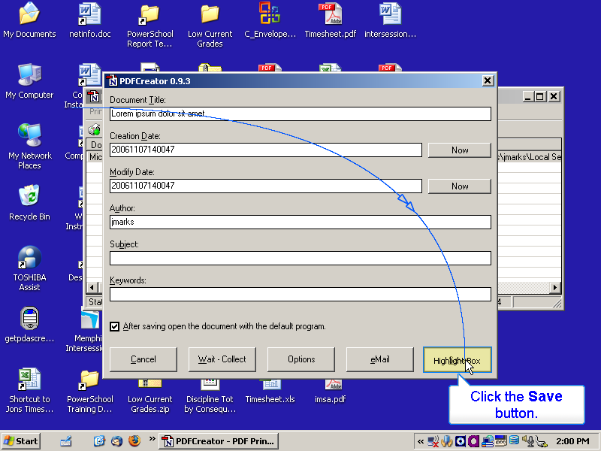

Click the Save button.

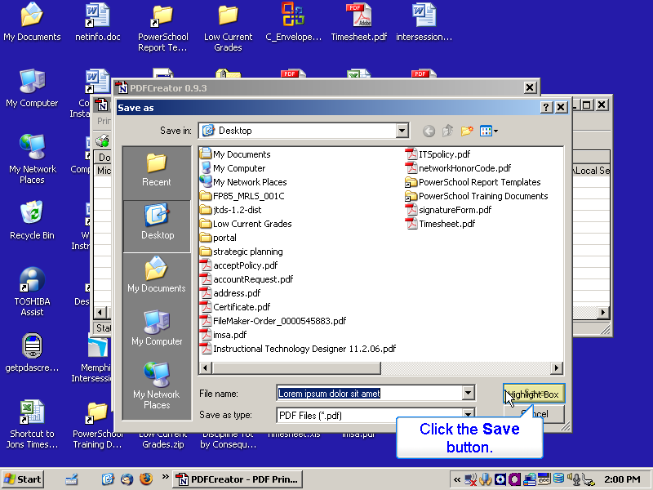

Click the Save button.

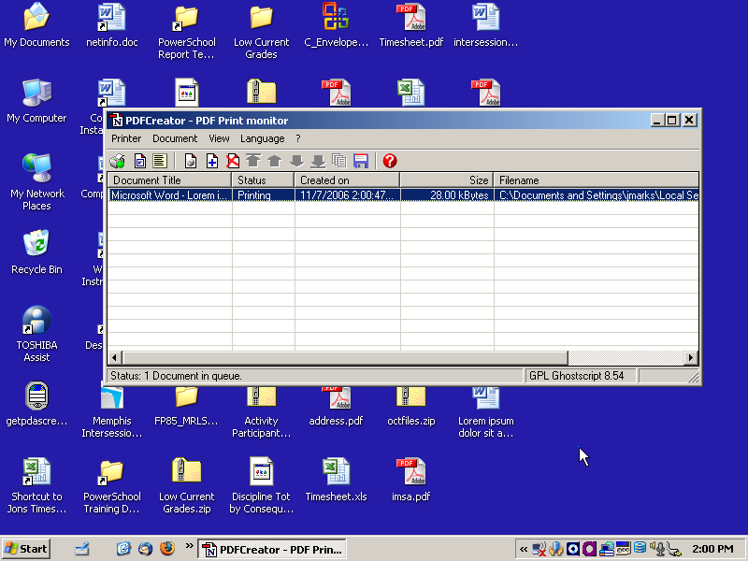

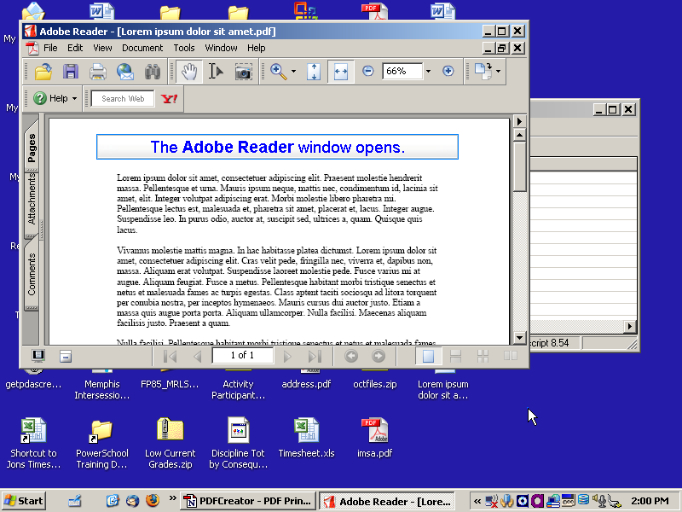

The Adobe Reader window opens.

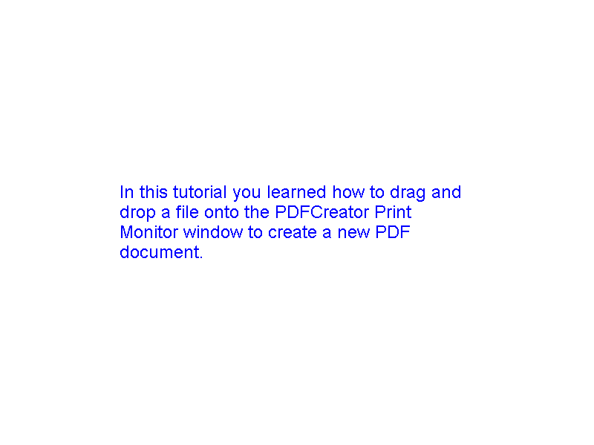

In this tutorial you learned how to drag and drop a file onto the PDFCreator Print Monitor window to create a new PDF document.

