Illinois Mathematics and Science Academy
Department of English
Rising Junior Summer Reading, 2018

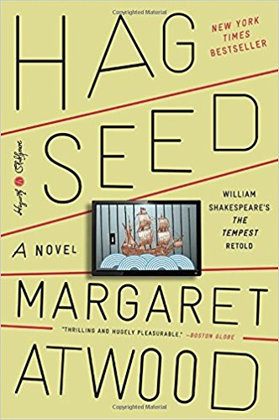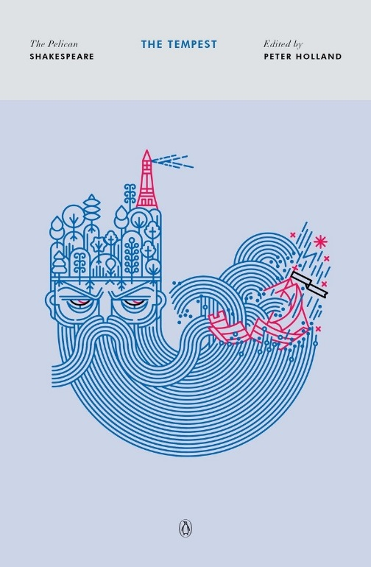
Margaret Atwood, Hag-Seed William Shakespeare, The Tempest
Hogarth Shakespeare The Pelican Shakespeare
ISBN 978-0804141314 ISBN 978-0143128632

Please try to purchase these particular editions for continuity in class.

Why has the English Team chosen these texts for summer reading?
Margaret Atwood’s 2016 novel Hag-Seed promises a contemporary retelling of William Shakespeare’s early seventeenth-century play The Tempest. By reading a classic work alongside a contemporary reimagination of it, students will have the opportunity to experience the same story in different genres, different time periods, and different stages of development of the English language. Both texts explore families, love, loss, power, revenge, magic, and performance—Shakespeare’s in the context of a Mediterranean island, and Atwood’s in the context of a contemporary Canadian prison.

Shakespeare? That sounds hard!
Even if students have encountered Shakespeare’s work before, The Tempest is likely to present them with new challenges. We encourage students to use the many resources available to aid their understanding, from Peter Holland’s introduction to online summaries to performances of the play on YouTube. That said, it’s crucially important for students to carefully read the language of the text itself, even if they use summaries to aid that reading.

Annotation and Careful Reading
As always, your teachers encourage the practice of careful annotation in all of your assigned reading at IMSA. Keep track of your impressions of the texts, the questions they raise for you, the language you find striking or difficult, and so forth. Doing so will help reinforce active reading habits and prepare you to be a strong participant in the first weeks of Literary Explorations III.

What can you expect in your English class at the beginning of the school year?
Students will be asked to discuss, debate, and identify important details and ideas drawn from the texts, which will serve as springboards for in-class activities and out-of-class assignments. Students should plan to keep their copies of both texts on campus throughout the fall, as their teacher may reference the texts throughout the course.

Guiding Questions
In addition to developing questions of your own, we encourage you to consider the following questions as you read these texts:

1. The Tempest is a play written in early modern English, and Hag-Seed is a novel written in contemporary English. What possibilities of meaning and narrative do these two different genres make available to readers and/or audiences? How has English changed in the years since Shakespeare’s time, and how has it stayed the same?

2. Both texts are set in spaces of isolation and exclusion: an island in The Tempest, and a prison in Hag-Seed. How do these spaces of confinement function to further the conflicts, tensions, and meanings of the two texts? Why do you think Atwood sees a prison as the most appropriate contemporary reframing of the island?

3. Shakespeare’s play is famously full of magic—Prospero is a sorcerer, and Ariel is a spirit who does his bidding. How does Atwood translate the idea of “magic” into her contemporary work?

4. The paperback cover of Hag-Seed describes it as “William Shakespeare’s The Tempest Retold.” In your reading, does Hag-Seed seem most like a retelling of Shakespeare’s play, an homage to it, or an entirely new work?

