NOTE: Do not depend on antihistamines or inhalers (bronchodilators) to treat a severe reaction. USE EPINEPHRINE.
Extremely reactive to the following allergens:_________________________________________________________
THEREFORE:
- If checked, give epinephrine immediately if the allergen was LIKELY eaten, for ANY symptoms.
- If checked, give epinephrine immediately if the allergen was DEFINITELY eaten, even if no symptoms are apparent.

FOR ANY OF THE FOLLOWING:
SEVERE SYMPTOMS
MILD SYMPTOMS

NOSEMOUTHSKINGUT
Itchy orItchy mouthA few hives,Mild runny nose,mild itchnausea or
sneezingdiscomfort

FOR MILD SYMPTOMS FROM MORE THAN ONE
SYSTEM AREA, GIVE EPINEPHRINE.

FOR MILD SYMPTOMS FROM A SINGLE SYSTEM
AREA, FOLLOW THE DIRECTIONS BELOW:
Antihistamines may be given, if ordered by a healthcare provider.
Stay with the person; alert emergency contacts.
Watch closely for changes. If symptoms worsen, give epinephrine.

LUNG
Shortness of breath, wheezing, repetitive cough

SKIN
Many hives over body, widespread redness

HEART
Pale or bluish skin, faintness, weak pulse, dizziness

GUT
Repetitive vomiting, severe diarrhea

THROAT
Tight or hoarse throat, trouble breathing or swallowing

OTHER
Feeling something bad is about to happen, anxiety, confusion

MOUTH
Significant swelling of the tongue or lips

OR A
COMBINATION
of symptoms from different body areas.



Name: D.O.B.:
Allergic to: Weight: lbs. Asthma: □ Yes (higher risk for a severe reaction)□ No
PLACE PICTURE HERE
- INJECT EPINEPHRINE IMMEDIATELY.
MEDICATIONS/DOSES
Epinephrine Brand or Generic:

Epinephrine Dose: □ 0.1 mg IM □ 0.15 mg IM □ 0.3 mg IM
Antihistamine Brand or Generic: Antihistamine Dose:
Other (e.g., inhaler-bronchodilator if wheezing):
- Call 911. Tell emergency dispatcher the person is having anaphylaxis and may need epinephrine when emergency responders arrive.
- Consider giving additional medications following epinephrine:
» Antihistamine
» Inhaler (bronchodilator) if wheezing
- Lay the person flat, raise legs and keep warm. If breathing is difficult or they are vomiting, let them sit up or lie on their side.
- If symptoms do not improve, or symptoms return, more doses of epinephrine can be given about 5 minutes or more after the last dose.
- Alert emergency contacts.
- Transport patient to ER, even if symptoms resolve. Patient should remain in ER for at least 4 hours because symptoms may return.

PATIENT OR PARENT/GUARDIAN AUTHORIZATION SIGNATURE DATE PHYSICIAN/HCP AUTHORIZATION SIGNATURE DATE



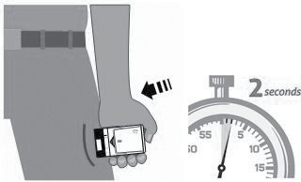
3
Remove Auvi-Q from the outer case. Pull off red safety guard. Place black end of Auvi-Q against the middle of the outer thigh.
Press firmly until you hear a click and hiss sound, and hold in place for 2 seconds.
Call 911 and get emergency medical help right away.
1.
2.
3.
4.
HOW TO USE AUVI-Q® (EPINEPHRINE INJECTION, USP), KALEO

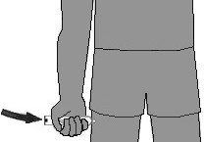
4
Remove the EpiPen® or EpiPen Jr® Auto-Injector from the clear carrier tube.
Grasp the auto-injector in your fist with the orange tip (needle end) pointing downward. With your other hand, remove the blue safety release by pulling straight up.
Swing and push the auto-injector firmly into the middle of the outer thigh until it ‘clicks’. Hold firmly in place for 3 seconds (count slowly 1, 2, 3).
Remove and massage the injection area for 10 seconds. Call 911 and get emergency medical help right away.
1.
2.

3.

4.
HOW TO USE EPIPEN®, EPIPEN JR® (EPINEPHRINE) AUTO-INJECTOR AND EPINEPHRINE INJECTION (AUTHORIZED GENERIC OF EPIPEN®), USP AUTO-INJECTOR, MYLAN AUTO-INJECTOR, MYLAN

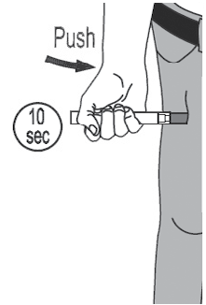
Pull off both blue end caps: you will now see a red tip. Grasp the auto-injector in your fist with the red tip pointing downward.
Put the red tip against the middle of the outer thigh at a 90-degree angle, perpendicular to the thigh. Press down hard and hold firmly against the thigh for approximately 10 seconds.
4. Remove and massage the area for 10 seconds. Call 911 and get emergency medical help right away.
5
Remove epinephrine auto-injector from its protective carrying case.
1.
2.
3.
HOW TO USE IMPAX EPINEPHRINE INJECTION (AUTHORIZED GENERIC OF ADRENACLICK®), USP AUTO-INJECTOR, AMNEAL PHARMACEUTICALS

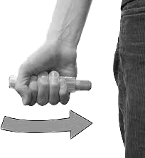
Quickly twist the yellow or green cap off of the auto-injector in the direction of the “twist arrow” to remove it.5
Grasp the auto-injector in your fist with the orange tip (needle end) pointing downward. With your other hand, pull off the blue safety release.
Place the orange tip against the middle of the outer thigh at a right angle to the thigh.
Swing and push the auto-injector firmly into the middle of the outer thigh until it ‘clicks’. Hold firmly in place for 3 seconds (count slowly 1, 2, 3).
Remove and massage the injection area for 10 seconds. Call 911 and get emergency medical help right away.
5.
HOW TO USE TEVA’S GENERIC EPIPEN® (EPINEPHRINE INJECTION, USP) AUTO-INJECTOR, TEVA PHARMACEUTICAL INDUSTRIES
1.
2.

3.
4.

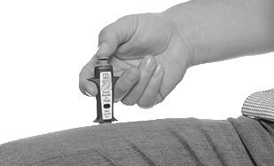
When ready to inject, pull off cap to expose needle. Do not put finger on top of the device.2
Hold SYMJEPI by finger grips only and slowly insert the needle into the thigh. SYMJEPI can be injected through clothing if necessary.
After needle is in thigh, push the plunger all the way down until it clicks and hold for 2 seconds.
Remove the syringe and massage the injection area for 10 seconds. Call 911 and get emergency medical help right away. Once the injection has been administered, using one hand with fingers behind the needle slide safety guard over needle.
3.
4.
5.
HOW TO USE SYMJEPI™ (EPINEPHRINE INJECTION, USP)
1.
2.

ADMINISTRATION AND SAFETY INFORMATION FOR ALL AUTO-INJECTORS:
- Do not put your thumb, fingers or hand over the tip of the auto-injector or inject into any body part other than mid-outer thigh. In case of accidental injection, go immediately to the nearest emergency room.
- If administering to a young child, hold their leg firmly in place before and during injection to prevent injuries.
- Epinephrine can be injected through clothing if needed.
- Call 911 immediately after injection.
OTHER DIRECTIONS/INFORMATION (may self-carry epinephrine, may self-administer epinephrine, etc.):
Treat the person before calling emergency contacts. The first signs of a reaction can be mild, but symptoms can worsen quickly.
NAME/RELATIONSHIP: PHONE:
PARENT/GUARDIAN: PHONE:
NAME/RELATIONSHIP: PHONE:
DOCTOR: PHONE:
OTHER EMERGENCY CONTACTS
NAME/RELATIONSHIP: PHONE:
EMERGENCY CONTACTS — CALL 911
RESCUE SQUAD:

